Modifications to JAVA Assignments
You can add extra features to any of the assignments for higher marks. A 4+ is going beyond the basic assignment. Here are a few suggestions to get you started:
You can round numbers to a certain number of decimal places when needed (see Notes folder).
Modify “Hangman” to make it a two-player game. Have it display which player’s turn it is. When a player guesses a letter correctly, they get to go again. When they guess it wrong, the turn switches to the other player. Have a “guess” button that they can click to enter a guess. If they guess correctly they win (and all the letters are displayed). If not, the turn switches to the other player. The hangman still exists … if the person gets hanged then both players lose.
Modify “Memory Game” so that instead of having pairs of cards, all the cards have different numbers. Now to make a match, the player has to find two consecutive cards (i.e. the values are 1 apart). You could also make the first and last card a match – otherwise the player could end up in a situation that is impossible to win.
Modify “Memory Game” to use images instead of numbers.
Modify “Koch Curve” to make fractal snowflakes:
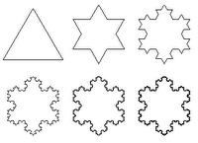
Modify “Koch Curve” to resize when the window is resized.
Modify “Fractal Trees” to make the following type of trees:
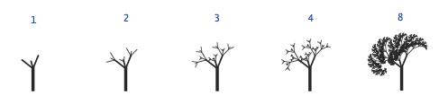
Modify “Fractal Trees” to resize when the window is resized.
Modify “Bounce” to use back-buffering and resize when the window resizes.
Add more different types of components to “components”.
Animate string assignments, or extend the pattern, or make other patterns.
Make “Random Person” read the names into an array before picking one. Make a user interface. Allow the user to click to regenerate.

